STUDENT’S PERSONAL INFORMATION
First Middle Last
Name
Date of Birth | ............../............/................ (Date/Month/Year) Age : Year ..................... Month ..................
Place of Birth | City.....................................................State....................................Country..............................
Father’s Name | ...........................................................Occupation...............................Mobile...........................
Mother’s Name | ...........................................................Occupation...............................Mobile...........................
Class |  |  |  |  |  |  |  |  |  |  |  |  |  |  | Gender Male Female
Present Address | ..........................................................................................Email..............................................
Permanent Address | ..................................................................................................................................................
Caste Category | GEN OBC SC ST (As per Govt. Stipulations)
Mother Tongue | Hindi English Other................................
Nationality | Indian Other...............................
If Child is adopted | Yes (Since Year......................................)
Date : ............................................
Signature of Parent / Guardian
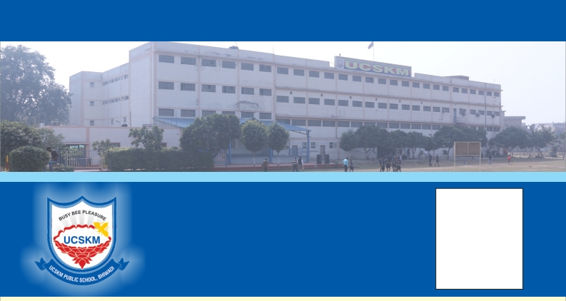UCSKM PUBLIC SCHOOL

UTOPIA-COL. SATSANGI'S KIRAN MEMORIAL
PUBLIC SCHOOL
BHIWADI (Raj.) Ph. : 01493-298081, 82
(afliated to C.B.S.E. New Delhi)
Set up on lines of CSKM Public School, Satbari, New Delhi
e-mail : info@ucskm.org Web. : www.ucskmschool.com

STUDENT’S
PHOTO

ADMISSION No.
HOUSE
BUS
YES
NO

Please read this carefully and seek admission only if you are genuinely convinced and not as a contingency due to your urgent need at the moment, to later
feel or say that this is unfair and other schools do not do it etc.
I hereby apply for admission as per details given below. I agree to abide by rules and regulations framed/changed without any referece/conference to/by me
& hereby give up all rights/claims now & in future, to challenge any of these in any way legal or otherwise, whatsoever, I seek this admission after full
knowledge & conviction of the excellent/unique setup of the institution including its special characteristics of living style/educational process, which may be
considered rather unusual by many. I willfully respect the Customs & Philosophy of institution regarding festivals, holidays, leaves & dress etc. and I know
that I am doing it for ultimate benet, growth & development of my child & entirely at my cost & risk, with full faith in the best efforts of the institution & I fully
understand that the institution & its staff will in no way be considered responsible for any mishap/failures whatsoever (God forbid) Physical harm to the child
due to any act of commission / omission of the institution or its staff.

Last 3 Schools Attended Since | Board | Academic  Class  From To | Record  Years of Study  From To | Medium | Rank | Co-Curricular  Achievement
1.
2.
3.
Physical Information : To be veried  Height (In cm) ........................... Weight (In Kg.) ................... | by Medical Incharge of the School  Left Eye Sight ......................... Right Eye Sight ....................
Skin Complexion / Color | Fair Whitish Dark Other ...................
Blood Group | A+ A- B+ B- O+ O- AB+ AB-
Mark of Identication on Body
Any Physical Disability / Challenged
Allergies (if any)
Drugs prohibited for above Allergies
Family Doctor
ADMISSION  Academic Test Report | TEST Details  Marks | Examiner’s Name & Signature
Subject
1.
2.
3.
VERY STRONG | STRONG | AVERAGE | TENDER | WEAK

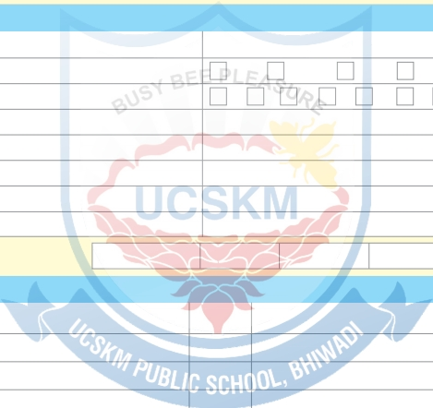Details of Siblings

I willfully agree to abide by the following rules & regulations regarding payment of fees etc.
No. of Brothers .......................................... No. of Sisters........................................... Sibling in UCSKM....................
Physical Endurance / Stamins :
Remarks
............................................ Signature Admission I/C
.

a)
All fees are chargeable on FULL SESSION BASIS irrespective of the date of admission. However as a concession to Transfer cases of MID-
SESSION only 2 months fees may be charged as arrear as on the date of admission.

.

b)
Late Grace Fee of Rs. 10/- per day for any type of dues will be charged after 11th of that month

.

c)
Existing rate of fees is linked with CONSUMER PRICE INDEX and D.A. announced from time to time by the GOVT. OF INDIA. The
announcement by the Govt. will be considerd as NOTICE to parents and fee will be required to be paid as calculated, ipso facto and
automatically according to the Govt. announcement.

.

d)
Two clear months notice is a must in all cases, if the child is to be withdrawn otherwise two months fees will be charged in lieu thereof. This

is to avoid hasty and not fully considered decisions.
I fully agree with the above terms and conditions and assure to follow the same under all circumstances
SIGNATURE OF PARENT / GUARDIAN......................................
NAME OF SIGNATORY ............................................. RELATIONSHIP WITH THE CHILD ...........................................

TICK THE DOCUMENT SUBMITTED SIGNATURE OF PARENT / GUARDIAN
BIRTH CERTIFICATE ............................................

TRANSFER CERTIFICATE ............................................

REPORT CARD ............................................

ID PROOF OF PARENTS ............................................

2 PHOTOS OF STUDENT ............................................

2 PHOTOS OF PARENTS ............................................

If any document/s not submitted tick the time period when the same will be submitted, if all the required
documents will not be submitted within the time period marked the admission will be cancelled without notice.
1 WEEK 15 DAYS 1MONTH

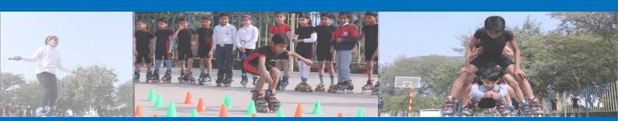FOR OFFICE USE

Payment of Registration fee vide MR No. and date ........................ signature of accountant ...................................

Admission offered – class ............................ Subjects offered ......................................................................................

Sign of Principal ........................................... & remarks if any ....................................................................................

After checking fees Rs. ................................. Paid vide MR No. ...................................... Date ..................................

Entered in long rolls at Serial No. ..................................................................................... Date ...................................

Parent's / Guardian's Sign.
Ofce Superintendent Sign.

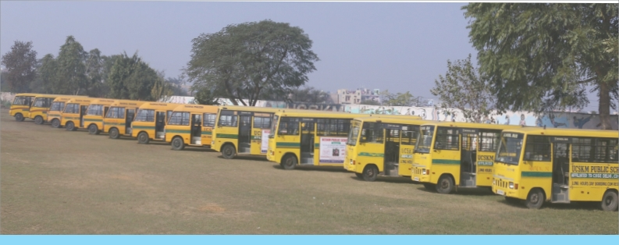TRANSPORT DETAILS

MOTHER’S
PHOTO
FATHER’S
PHOTO
GUARDIAN’S
PHOTO

Name of Student : .........................................................................................................................................................
School No. : ....................................................................................................... Class : ...............................................
Date of Admission : ........................................................................................... Date of Joining : ................................
Parent / Guardian : ......................................................................................................................................................
Address : ........................................................................................................................................................................
........................................................................................................................................................................................

Residence No.
Ofce No.
Mobile No.

Contact No.:

Status of Bus Charges : ............................................................................................. Route No. : ...............................
Details of Bus Stop : ......................................................................................................................................................

Distance (Tick the Applicable) Below 5 Kms.
Between 5 to 20 Kms.
More than 20 Kms.

Remarks : ......................................................................................................................................................................
........................................................................................................................................................................................
........................................................................................................................................................................................

Date : ...............................

Accounts
Parent’s / Guardian's Signature
OSD (Admission)

Principal

